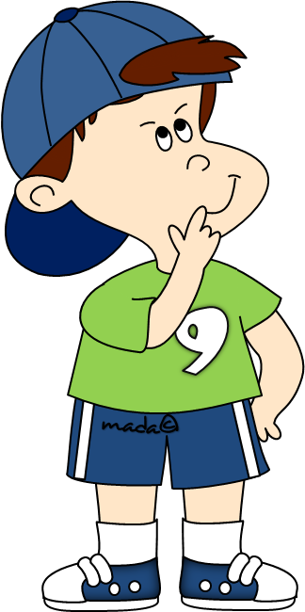
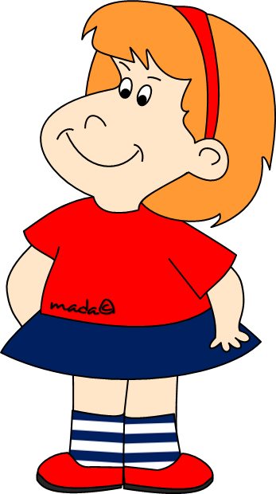
What time _ _ _ _ _ _ _ _ _ _ _ _ _ (the meeting/end)?
Tomorrow I _ _ _ _ _ _ _ _ _ _ _ _ (visit) my aunt, Sally.
Molly _ _ _ _ _ _ _ _ _ _ _ _ (speak) French but right now she _ _ _ _ _ _ _ _ _ _ _ _ (speak) Spanish.
We _ _ _ _ _ _ _ _ _ _ _ _ (not/finish) our history project yet. The deadline is set for Monday.
Kim _ _ _ _ _ _ _ _ _ _ _ _ (never/be) abroad. She’d love to visit other countries.
I’m exhausted. I _ _ _ _ _ _ _ _ _ _ _ _ (train) my stomach muscles all morning.
What _ _ _ _ _ _ _ _ _ _ _ _ _ (usually/you/do) in
your free time?
A: Look! Your mum’s in the vegetable garden.
_ _ _ _ _ _ _ _ _ _ (she/water) the tomatoes?
B: I guess, she _ _ _ _ _ _ _ _ _ _ _.

My sister and I _ _ _ _ _ _ _ _ _ _ _(prepare) a gala dinner to celebrate our parents’ silver anniversary.
Where _ _ _ _ _ _ _ _ _ _ _ (you/sit) when the light _ _ _ _ _
_ _ _ _ _ _ _ (go) off?
Liz _ _ _ _ _ _ _ _ _ _ _ (pain) the bathroom for two hours before Luke _ _ _ _ _ _ _ _ _ _ _ (offer) her his help.
When Vanda _ _ _ _ _ _ _ _ _ _ _ (be) on holiday last summer she _ _ _ _ _ _ _ _ _ _ _ (ride) a bike every day.
The kids _ _ _ _ _ _ _ _ _ _ _ (play) at the beach when they _ _ _ _ _ _ _ _ _ _ _ (hear) the roar of the ocean.
Sam _ _ _ _ _ _ _ _ _ _ _ (vacuum) the carpets before she
_ _ _ _ _ _ _ _ _ _ _ (settle) down with a book.
Mike _ _ _ _ _ _ _ _ _ _ _ (chop) the onions while Lucy
_ _ _ _ _ _ _ _ _ _ _ (blend) the eggs and cream.
Last year I _ _ _ _ _ _ _ _ _ _ _ (not/save) any money.
A: Remember that it’s a secret. B: I know. I
_ _ _ _ _ _ _ _ _ _ _ (not/tell) anyone, I promise.
Sue has bought some chocolates because she _ _ _ _ _ _
_ _ _ _ _ (visit) her grandpa in hospital.
I haven’t finished my essay yet but I _ _ _ _ _ _ _ _ _ _ _ (write) it by tomorrow.
At this time next week Brenda _ _ _ _ _ _ _ _ _ _ _ (sunbathe) on the Caribbean beach. I envy her.
We expect Tom _ _ _ _ _ _ _ _ _ _ _ (recover) soon.
What _ _ _ _ _ _ _ _ _ _ _ (you/do) tonight? Can we meet at 7? I need to talk to you.
Look at Greg. He _ _ _ _ _ _ _ _ _ _ _ (jump) into the swimming pool.
_ _ _ _ _ _ _ _ _ _ _ (you/stop) making so much
noise, please? Anna is studying for Maths exam.

_ _ _ _ _ _ _ _ _ _ rock band do you like best?
_ _ _ _ _ _ _ _ _ _ did Katie spend last Christmas?
_ _ _ _ _ _ _ _ _ _ don’t you join us?
_ _ _ _ _ _ _ _ _ _ did you pay for your new fur coat?
_ _ _ _ _ _ _ _ _ _ keys are these? I think they’re Bob’s.
_ _ _ _ _ _ _ _ _ _ does Harry go sailing? Once a month.
_ _ _ _ _ _ _ _ _ _ brothers have you got? Just one.
_ _ _ _ _ _ _ _ _ _ do they usually go to bed? At 11.30.
_ _ _ _ _ _ _ _ _ _ do we get there? By bus or by train.
10. _ _ _ _ _ _ _ _ _ _ is your cousin? She’s 9.
11. _ _ _ _ _ _ _ _ _ _ will grandma visit us? On Friday.
12. _ _ _ _ _ _ _ _ _ _ likes pizza? Everyone.
13. _ _ _ _ _ _ _ _ _ _ is Paris from Madrid? About
1200 km.
14. _ _ _ _ _ _ _ _ _ _ was your trip? Long and tiring.

Zoe _ _ _ _ _ _ _ read and write when she was six.
Remember, you _ _ _ _ _ _ _ talk to the driver. It’s forbidden.
_ _ _ _ _ _ _ your mum speak any foreign languages?
You _ _ _ _ _ _ _ go to bed early if you don’t feel very
well.
Mrs. Gillian _ _ _ _ _ _ _ open the window last night because the handle was broken.
The teacher_ _ _ _ _ _ _ get annoyed if you don’t do your homework again.
Stella _ _ _ _ _ _ _ be at home. I think she’s not feeling very well today.
You _ _ _ _ _ _ _ eat the dessert if you don’t want to.
Rick _ _ _ _ _ _ _ walk yet. He’s only seven months old.
10. You _ _ _ _ _ _ _ watch this film. It’s hilarious.

Has Fred done it _ _ _ _ _ _ _ or has anyone helped him?
Megan and Lea are twins. _ _ _ _ _ _ _ are like two peas in a pod.
I need to buy a new printer. Could you lend _ _ _ _ _ _ _ some money?
Fiona recommends this beauty salon although she has never been there _ _ _ _ _ _ _.
George and I are good listeners. You can always talk to
_ _ _ _ _ _ _ and _ _ _ _ _ _ _ will help you if we can.
We both have a sister, but _ _ _ _ _ _ _ is older than
_ _ _ _ _ _ _.
_ _ _ _ _ _ _ _ shoes are too expensive for me. I cannot afford to buy _ _ _ _ _ _ _.
Does _ _ _ _ _ _ _ _ know the correct answer?
We tried to get tickets, but there were _ _ _ _ _ _ _ left.

Angličtina – 9. Třída – testíček
- What time _ _ _ _ _ _ _ _ _ _ _ _ _ (the meeting/end)?
- Tomorrow I _ _ _ _ _ _ _ _ _ _ _ _ (visit) my aunt, Sally.
- Molly _ _ _ _ _ _ _ _ _ _ _ _ (speak) French but right now she _ _ _ _ _ _ _ _ _ _ _ _ (speak) Spanish.
- We _ _ _ _ _ _ _ _ _ _ _ _ (no/finish) our history project yet. The deadline is set for Monday.
- Kim _ _ _ _ _ _ _ _ _ _ _ _ (never/be) abroad. She’d love to visit other countries.
- I’m exhausted. I _ _ _ _ _ _ _ _ _ _ _ _ (train) my stomach muscles all morning.
- What _ _ _ _ _ _ _ _ _ _ _ _ _ (usually/you/do) in
your free time?
- A: Look! Your mum’s in the vegetable garden.
_ _ _ _ _ _ _ _ _ _ (she/water) the tomatoes?
B: I guess, she _ _ _ _ _ _ _ _ _ _ _.

Pokud jsi pečlivě vyplnil předchozí stránku, čeká tě velké počítání bodíků, na následující stránce je řešení, barevně oprav, co ti nevyšlo a napiš počet dosažených bodů, za každou správnou odpověď jeden.... to vše pošli zpět své vyučující.
Good luck☺

What time does the meeting end?
Tomorrow I am visiting my aunt, Sally.
Molly speaks French but right now she is speaking Spanish.
We haven’t finished our history project yet. The deadline is set for Monday.
Kim has never been abroad. She’d love to visit other countries.
I’m exhausted. I have been training my stomach muscles all morning.
What do you usually do in your free time?
A: Look! Your mum’s in the vegetable garden.
Is she watering the tomatoes?
B: I guess, she is.

My sister and I prepared a gala dinner to celebrate our parents’ silver anniversary.
Where were you sitting when the light went off?
Liz had been painting the bathroom for two hours before Luke offered her his help.
When Vanda was on holiday last summer she rode a bike every day.
The kids were playing at the beach when they heard the roar of the ocean.
Sam had vacuumed the carpets before she
settled down with a book.
Mike was chopping the onions while Lucy
was blending the eggs and cream.
Last year I didn’t save any money.
A: Remember that it’s a secret. B: I know. I
won’t tell anyone, I promise.
Sue has bought some chocolates because she is going to visit her grandpa in hospital.
I haven’t finished my essay yet but I will have written it by tomorrow.
At this time next week Brenda will be sunbathing on the Caribbean beach. I envy her.
We expect Tom will recover soon.
What are you doing tonight? Can we meet at 7? I need to talk to you.
Look at Greg. He is going to jump into the swimming pool.
Will you stop making so much noise, please? Anna
is studying for Maths exam.

What rock band do you like best?
Where did Katie spend last Christmas?
Why don’t you join us?
How much did you pay for your new fur coat?
Whose keys are these? I think they’re Bob’s.
How often does Harry go sailing? Once a month.
How many brothers have you got? Just one.
What time do they usually go to bed? At 11.30.
How do we get there? By bus or by train.
10. How old is your cousin? She’s 9.
11. When will grandma visit us? On Friday.
12. Who likes pizza? Everyone.
13. How far is Paris from Madrid? About
1200 km.
14. How was your trip? Long and tiring.

Zoe could read and write when she was six.
Remember, you mustn’t talk to the driver. It’s
forbidden.
Can your mum speak any foreign languages?
You should go to bed early if you don’t feel very
well.
Mrs. Gillian couldn’t open the window last night because the handle was broken.
The teacher may get annoyed if you don’t do your homework again.
Stella might be at home. I think she’s not feeling very well today.
You don’t have to eat the dessert if you don’t want to.
Rick can’t walk yet. He’s only seven months old.
10. You must watch this film. It’s hilarious.

Has Fred done it himself or has anyone helped him?
Megan and Lea are twins. They are like two peas in a pod.
I need to buy a new printer. Could you lend me some money?
Fiona recommends this beauty salon although she has never been there herself.
George and I are good listeners. You can always talk to
us and we will help you if we can.
We both have a sister, but mine/yours is older than
yours/mine.
These/Those shoes are too expensive for me. I cannot afford to buy them.
Does anyone know the correct answer?
We tried to get tickets, but there were none left.

