Label the picture.
Prepositions of place

1 …………………………
2 …………………………
3 …………………………
4 …………………………
5 …………………………
6 …………………………
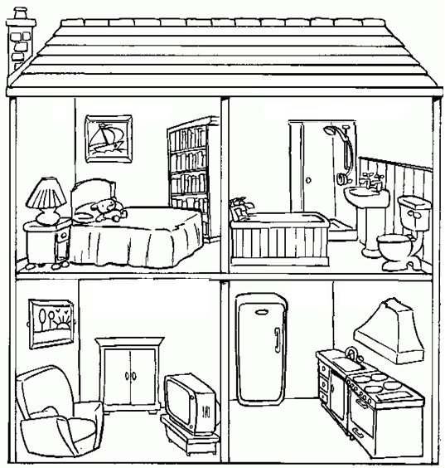
2
3
4
5
6
Remember

in the bedroom. on the bed.
in the kitchen. on the roof.
1 Where's the fridge?
……………………………………………
2 Where are the books?
…………………………………………….
3 Where's the teddy bear?
…………………………………………….
4 Where are the pictures?
…………………………………………….
5 Where's the lamp?
…………………………………………….
6 Where's the TV?
……………………………………………..
Write the answers
1

Look at the picture and write the missing prepositions in the sentences opposite.

in front of - near - on - in under - between - behind

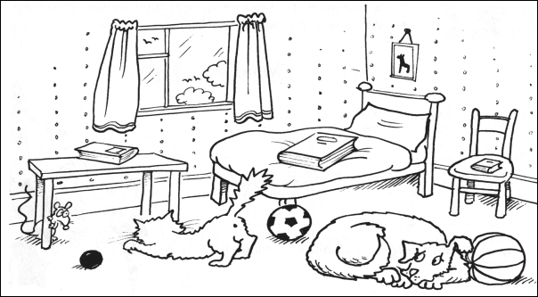
1 The picture is ……………… The wall.
2 The mouse is ………………. the table.
3 The table is ………………… The bed.
4 The dog is …………………. the two balls.
5 The chair is ………………..the bed.
6 The dog is …………………. The cat.
7 The mouse is …………………… the cat.
8 The cat is ……………………. The small ball and the big ball.
9 The balls are …………………….. the floor.
10 The cat and the dog are …………… the bedroom.

